Final Report
SUBJECT:
ARTificial iNTelligence(INT 404)
TOPIC:
Music Recommendation System

Submitted by:
Raghu Nandan Reddy Chamakura (11802833)
Vinay Chandh Reddy Kallem (11802887)
Section: K18GX
Under the Surveillance of
Mr. Sagar Pande
(Assistant Professor)


Table of contents:
Contents:
Introduction | 4-5
Related work | 6-7
Implementation | 8-15
Conclusion | 16
References | 17

Figures:
Data | 8-9
Pandas | 10
Train_test_split | 10-11
Random | 11-12
Tkinter | 12-13
Logic | 14-15

Introduction:
- Overview of project.
- Introduction to project.
Motivation.
Aim.
Scope.

Related work:
- On what basis project is designed?
- Any related work?

Implementation:
- What’s unique in project.
- Code which justifies the unique quantity in project.
- Description of project with pics.

Conclusion:
- Conclusion of the project.
- References.

Introduction

Overview:
The project is “Music Recommendation System”. Music Recommendation System means to recommend the music to the user based on his/her interests. Here in our project what we have done is recommended music for certain user based on his playlist for that we have extracted the data which contains multiple users and millions of songs and their playlist. And our project doesn’t end there, we have also recommend the songs which are on top listen list to the user and the show the listen count of the song.

Introduction to Project:
Motivation:
The motivation of the project is to help users to find interesting music in these huge catalogs, MRS research is still facing substantial challenges. In particular, when it comes to build, incorporate, and evaluate recommendation strategies that integrate information beyond simple user-time interactions or content-based descriptors, but dig deep into the very essence of listener needs, preferences, and intentions.

Aim:
The objective of this project is to develop a music recommendation system. The system will determine the musical preferences of the users based on the analysis of their interaction during use. This system helps users discover new artists, albums or songs making the musical catalog available of listening. A music recommender needs a music catalog to be recommended, this project offers a review of several music services and their features, making use of information available from a database of friendly music services.

Scope:
The scope of the project is outlined below:

- Create a music recommendation system able to infer the user’s musical preferences in a given time. The scope is not to know the user, instead it’s about estimating what he could like right now.
- Explore the music services available nowadays looking for a complete and freely accessible music catalog and free music.

Related Work
Dataset:
We used data provided by 10 thousand songs data challenge. It is also very large and contains around 9500 (userid, songid, play count) triplets collected from histories of over a thousand’s of users and metadata of thousand’s of songs. But the users are anonymous here and thus information about their demography and timestamps of listening events is not available. The feedback is implicit as play count is given instead of explicit rating. From the huge amount of song metadata, we focus only on features that seem to be most relevant in characterizing a song. We decided that information like year, duration etc. may distinguish a song most from other songs. To increase processing speed, we converted user and song ids from strings to integer numbers.

Algorithms:
Popularity based model:
It is the most basic and simple algorithm. We find the popularity of each song by looking into the training set and calculating the number of users who had listened to this song. Songs are then sorted in the descending order of their popularity. For each user, we recommend top most popular songs except those already in his profile. This method involves no personalization and some songs may never be listened in future.

Playlist based model:
Playlist filtering involves collecting information from his listening songs and then making predictions based on some similarity measures between songs and between play count. This can be classified into user-based and item-based models.

Existing work:

No Existing Work. Everything is Completed.

Implementation
Uniqueness of the project:
In our project we used two models to filter the recommendations to the user.
playlist model:
we used the play count of the user’s playlist song and generated the recommendations of the songs. Here the songs are bound to the user’s playlist only.

Popularity model:
We find the popularity of each song by looking into the training set and calculating the number of users who had listened to this song.

Figures (libraries used in code):

DATASET:

We used data provided by 10 thousand songs data challenge. It is also very large and contains around 9500 (userid, songid, play count) triplets collected from histories of over a thousand’s of users and metadata of thousand’s of songs. But the users are anonymous here and thus information about their demography and timestamps of listening events is not available.

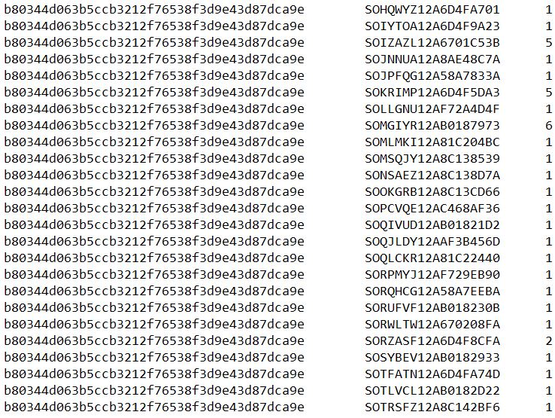
A Small Extracted Part of Data-1

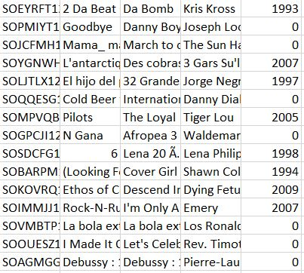

A Small Extracted Part of Data-2

PANDAS:

Pandas is an opensource library that allows to you perform data manipulation in Python. Pandas library is built on top of Numpy, meaning Pandas needs Numpy to operate. Pandas provide an easy way to create, manipulate and wrangle the data. Pandas is also an elegant solution for time series data.
Here in our program we have used pandas to import the data from the database to console.
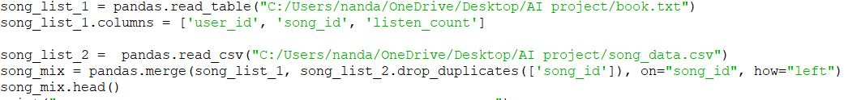

Pandas Code

From Sklearn.model_selection imported train_test_split:

Train/Test Split. As I said before, the data we use is usually split into training data and test data. The training set contains a known output and the model learns on this data in order to be generalized to other data later on. We have the test dataset (or subset) in order to test our model's prediction on this subset.
From dataset the old data is retrieved to the console and later using train_test_split trained data is created and later it participates in recommendation system.

train_test_split Code

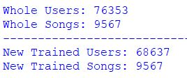

train_test_split Output

Random:

Python - Random Module. Functions in the random module depend on a pseudo-random number generator function random(), which generates a random float number between 0.0 and 1.0. random. random(): Generates a random float number between 0.0 to 1.0. The function doesn't need any arguments.
In program we used the random() function to get random popular songs from the trained data based on dataset of songs.
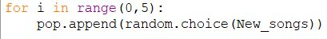
Random Code

Tkinter:

Tkinter is the standard GUI library for Python. Python when combined with Tkinter provides a fast and easy way to create GUI applications. Tkinter provides a powerful object-oriented interface to the Tk GUI toolkit.
Here in program we used tkinter to create GUI to the user recommended songs based on his playlist and popular song in dataset based on listen count of the songs.
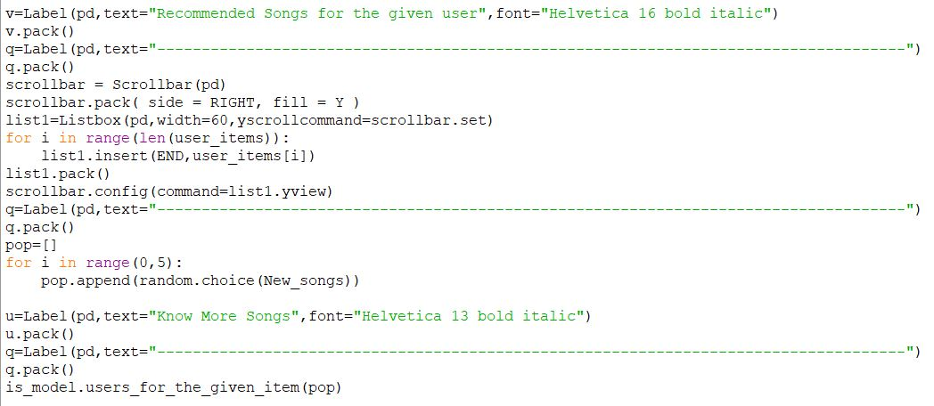

Tkinter Code

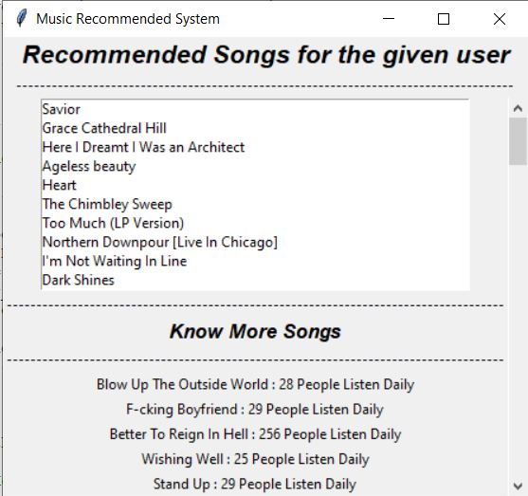

Tkinter Output

Logic:

The main key logic where the program is based on is given here. In the following image you can see how recommended songs are generated. The playlist based recommendation is done using the popularity based recommendation is done using random function and the data is imported from the subpart of playlist part of code.
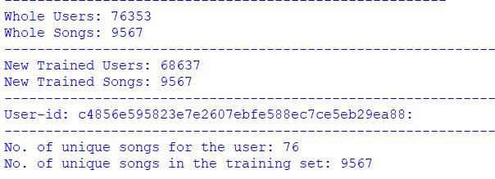

Whole Output
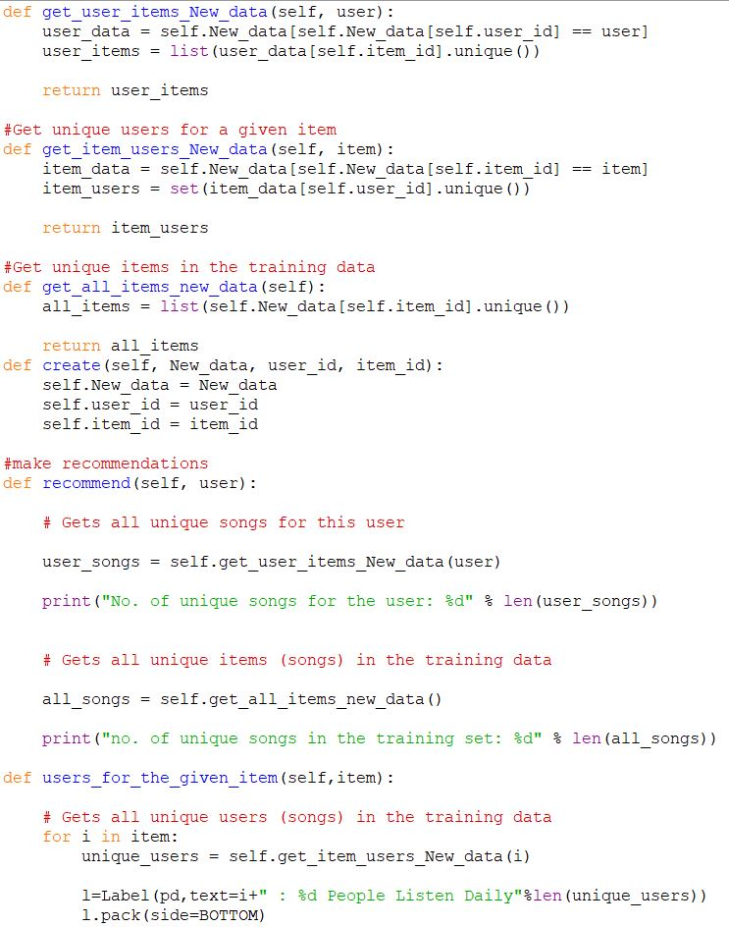
Main Logic

Conclusion:

We have learnt that Recommended Songs are based on Listener’s Playlist. Also, We have learnt various different modules that we have implemented to crack the logic into an Output. Also, We have built a popularity based model, i.e., Pick a random song from the Songs Dataset and the output is Knowing how many Users listen that Song to know it’s popularity.
Many apps like Gaana, Wynk Music, Hungama, Jio Saavn etc., have this music recommendation Systems, that makes a user easier to get to his daily listening routine songs. Our Model is a similar type of that.
Hence, we can say that a Recommendation System can be used in any platform that makes the approach Easier, Faster and Smoother.

References:
- https://musicbiz.org/news/playlists-overtake-albums-listenership-says-loop-study.

- https://press.spotify.com/us/about.

- http://www.nielsen.com/us/en/insights/reports/2017/music-360-2017-highlights.html.

- https://www.dezyre.com/projects/data-science-projects/machine-learning-projects-in-python.

- https://medium.com/@briansrebrenik/introduction-to-music-recommendation-and-machine-learning-310c4841b01d.

- http://www.pandora.com/about/mgp.

